A New Molecule for Post Operative Pain Management

Dr.P.Selvakumar
Chief Cardio Thoracic Anaesthesialogist
Apollo speciality Hospital
Madurai.

Clinical definition of pain1
“An unpleasant sensory and emotional experience associated with actual or potential tissue damage, or described in terms of such damage...

Objectives

- Types of pain
- Pain physiology
- Multimodal analgesia
- Intravenous agents used for postoperative pain
- Conclusions

Pain: Clinical Types

- Nociceptive pain
  - Transient pain in response to noxious stimuli

- Inflammatory pain
  - Spontaneous pain and hypersensitivity to pain in response to tissue damage and inflammation

- Neuropathic pain
  - Spontaneous pain and hypersensitivity to pain in association with damage to or a lesion of the nervous system

Neuropathic pain

- May respond to
  - local anaesthetic
  - Anticonvulsants
  - antidepressants
- Less responsive to opioids
- No response to NSAID’s, coxibs, or paracetamol

Consequences of Unrelieved Pain
Acute Pain

- Increased sympathetic activity
- GI effects
- Splinting, shallow breathing
- Increased catabolic demands
- Anxiety and fear
- Peripheral/ central sensitization
- Myocardial O2 consumption
- GI motility↓
- Atelectasis, hypoxemia, hypercarbia
- Poor wound healing/muscle breakdown
- Sleeplessness, helplessness
- Available drugs
- Myocardial ischemia
- Delayed recovery
- Pneumonia
- Weakness and impaired rehabilitation
- Psychological

Physiology & pharmacological management of postoperative pain

“Real World”: Multimodal Analgesia

IV paracetamol – premise

“Is more effective & has a faster onset than oral paracetamol”

Means of pain intensity differences (VAS)

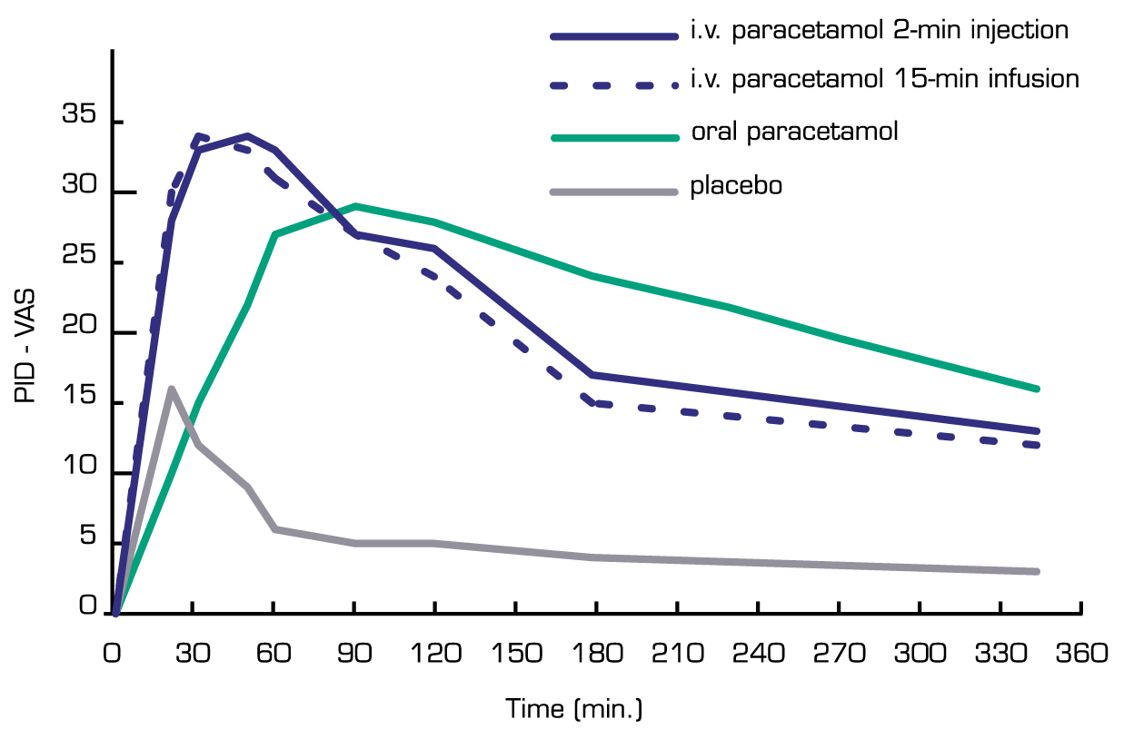
Means of pain intensS)
ity differences (VAS)

Paracetamol: clinical pharmacology
Paracetamol: a well known analgesic agent

- First proper account of clinical use in 1894 (Hinsberg and Treupel)1
- Analgesic effect formally demonstrated in 1948 (Flinn and Brodie)1
- Recommended first-line analgesic therapy:
- for the treatment of osteoarthritis since 20002,3
- for musculoskeletal pain in elderly since 20024
- for patients with renal disease since 19965

Paracetamol – how does it work?

- Paracetamol is a centrally acting agent
- It selectively inhibits nervous system PG synthesis2,3 probably via COX-3
- Other central mechanisms of action depend on the bulbo-spinal serotoninergic pathway4,5

What were the challenges?

Making paracetamol soluble
→ Use of hydrophilic ingredients (mannitol and disodium phosphate)

2. Ensuring its stability in solution
By controlling hydrolysis → Use of a pH buffer (disodium phosphate and sodium hydroxide)
By preventing oxidation
→ Addition of cysteine hydrochloride
→ Oxygen-free manufacturing process

Phase III clinical trials1,2 VS. placebo

ORGAN SAFETY

Hepatic safety at therapeutic doses1

- paracetamol hepatotoxicity was found to be very rare (<1 / 2,500)1
- It was always related to misuse and overdose
(>4g / day)1

Renal safety

- Up to 4g / day, paracetamol has an excellent renal safety profile1
- No evidence exists for the development of chronic
nephropathy with paracetamol2
- Recommended by the National Kidney Foundation as the non-narcotic analgesic of choice in patients with underlying renal disease 3

Paracetamol safety benefits in POP

- No centrally mediated side-effects1
- (e.g. sedation, constipation, nausea, vomiting, respiratory depression)
- No effect on platelet aggregation, bleeding, or uric acid excretion2
- No gastrointestinal side effects3
- Good renal4 and hepatic5 safety
- Few contra-indications and drug interactions

Storage

- Shelf life is 2 years
- Do not store above 30°C
- Do not refrigerate or freeze

Conclusions

- Perfalgan is a fast-acting analgesic, as effective as morphine 10mg1
- Perfalgan is a proven opioid-sparing agent2
- Perfalgan is well tolerated in all types of patients
- Perfalgan is ready-to-use and cost-effective3

